Sri Lanka Institute of Information Technology


IT1040 - Fundamentals of Computing
Year 1, Semester 1- 2025

Mirai
RFID-based Smart Vehicle Parking System

Progress Report
Y1S1Mtr9

IT Number | Name
IT25103889 | Edirisinghe U. K.
IT25103890 | Randil P. M. L.
IT25103891 | Malshika U. L. J.
IT25103892 | Usman M. N. M.
IT25103893 | Chandrasekara P. V. A.
IT25103894 | Ranasinghe K. S. S.

Introduction
The Mirai Smart Parking System is IoT based smart parking management solution to automate vehicle entrance, identify parking slots, calculate parking costs, and manage parking lot operations via wireless communication. The parking system consists of an ESP32 microcontroller as the main controller, which provides the mechanisms to connect the physical components of the system to the internet. Further, the ESP32 has several types of sensors, specifically radio frequency identification (RFID) tags to identify vehicles, ultrasonic sensors to detect vacant parking slots, and servo motors to control the opening/closing of the entrance gates to the parking area. it also has an OLED screen that presents slot information regarding the availability of parking spots to the parking facility.
It connects via REST API over the Internet to a cloud-hosted back-end server that does most of the heavy lifting for the parking system. The cloud server manages all aspects of parking space manipulation, generates cost estimates for each vehicle that parks in its facility, saves historical data for each user's vehicle, and creates reports for users showing how often they are using the facility. The web dashboard for the parking administrator displays current parking utilization, allows the administrator to view and clear user accounts, and provides administrator-generated financial and usage reports in real time. Several safety features, including smoke detection devices and buzzer alarms, have been included to ensure the reliability of the system.

System Architecture
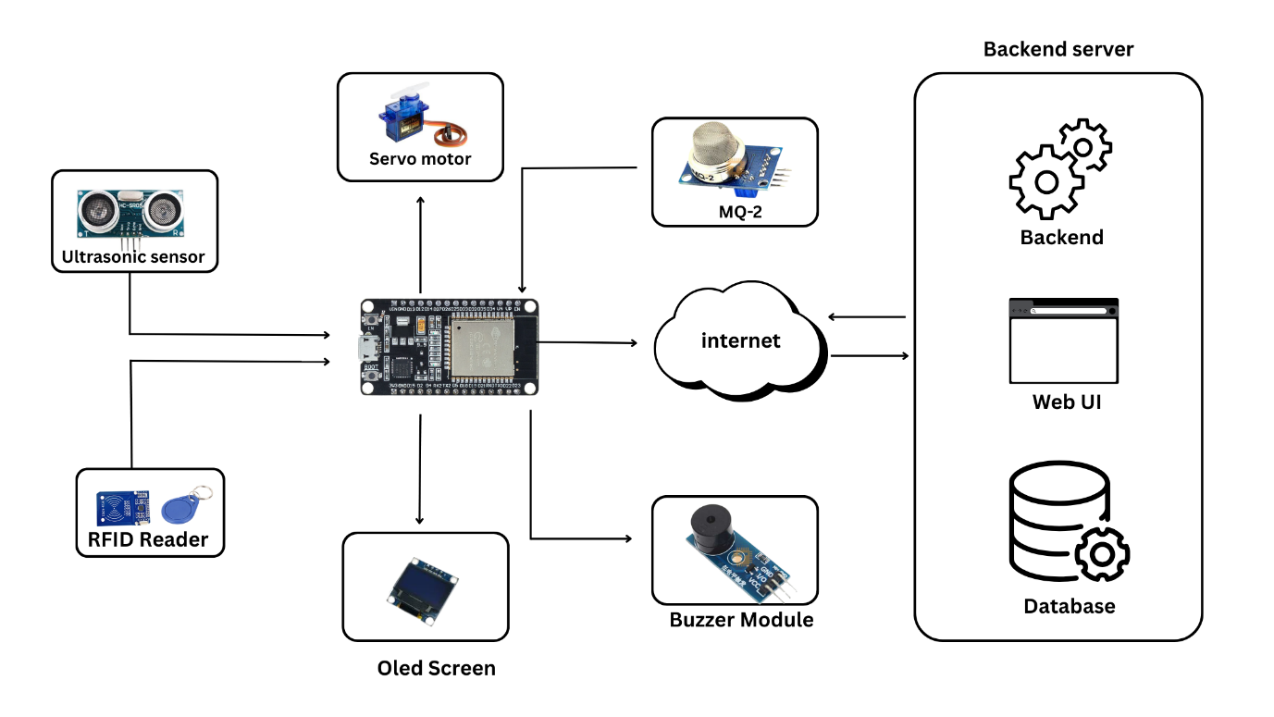

The system is built around an ESP32 microcontroller, which acts as the central controller connecting all sensors, actuators, and the cloud server.
- RFID Reader: Identifies vehicles and drivers for access control.
- Ultrasonic Sensor (HC-SR04): Detects parking slot occupancy by measuring distance.
- MQ-2 Smoke Sensor: Detects smoke or gas for fire safety.
- Servo Motor: Controls the parking gate (open/close).
- OLED Display: Shows welcome messages, slot availability, and alerts.
- Buzzer: Provides audible alerts during fire/smoke detection.
- Node MCU (ESP32-32U): Central processing unit that connects to the sensors, It also communicates with the cloud or web application through Wi-Fi, providing real-time parking details to the backend server.
- Backend Server: Handles business logic, cost calculation, and data processing. Stores data in a database such as vehicles, parking history and parking revenue. And provides REST APIs for communication with ESP32 and web UI.
- Web UI: Display real-time parking availability and allows admin control report generation and revenue monitoring.
The system uses the ESP32 to control the hardware components in the system. An arriving vehicle is scanned by the RFID reader, and the servo motor opens the gate if the vehicle has permission to enter. Ultrasonic sensors monitor each parking space status and inform the server of this detail in real-time.
All information is transmitted to a backend server through the internet. All information regarding parking time, rate, and reports is determined and recorded. The OLED display provides information about available slots and dispenses welcome messages. A web dashboard provides information about parking and vehicle management to administrators.

Work Breakdown Structure

Proof of Work
